**Mechatronics Laboratory**

**Rubik’s Cube 3x3 Simulator User Guide**

**Overview**

* **Color Code**

This Rubik’s cube simulator enumerates the list of available colors in the following way:

|  |  |
| --- | --- |
| **Color** | **Code** |
| White | 0 |
| Blue | 1 |
| Red | 2 |
| Green | 3 |
| Orange | 4 |
| Yellow | 5 |

* **Cube Movements code**

This Rubik’s cube simulator can perform up to 18 movements:

|  |  |  |
| --- | --- | --- |
| **Movement** | **Description** | **Code** |
| U | Up face (CW) | 0 |
| U2 | Up face (CW double turn) | 1 |
| U’ | Up face (CCW) | 2 |
| B | Back face (CW) | 3 |
| B2 | Back face (CW double turn) | 4 |
| B’ | Back face (CCW) | 5 |
| R | Right face (CW) | 6 |
| R2 | Right face (CW double turn) | 7 |
| R’ | Right face (CCW) | 8 |
| F | Front face (CW) | 9 |
| F2 | Front face (CW double turn) | 10 |
| F’ | Front face (CCW) | 11 |
| L | Left face (CW) | 12 |
| L2 | Left face (CW double turn) | 13 |
| L’ | Left face (CCW) | 14 |
| D | Down face (CW) | 15 |
| D2 | Down face (CW double turn) | 16 |
| D’ | Down face (CCW) | 17 |

**NOTE: This simulator assumes that green is the Front face and white is the Up face.**

* **Local Server**

This Rubik’s cube simulator internally leverages a local server, which may be accessed by using TCP/IP client.

|  |  |
| --- | --- |
| **Host** | **Port** |
| “localhost” (127.0.0.1) | 2500 |

**Commands**

To send commands to the local server, the next packet format must be assembled:



* **Set Cube State command**

This command sets the initial state of the cube.

|  |  |
| --- | --- |
| CMD | 0xFA (hex) |
| PAYLOAD LENGTH | 48 |
| PAYLOAD | 48 byte array |

The cube has six sides. Each side has eight movable faces. In total there are 48 movable faces. The payload must contain an array of 48 bytes representing the movable faces.

Face numbers are 0 to 47. The diagram below shows all the face numbers.

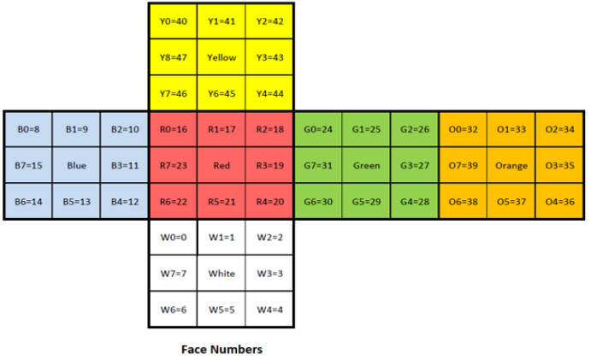

**Code example (MATLAB)**

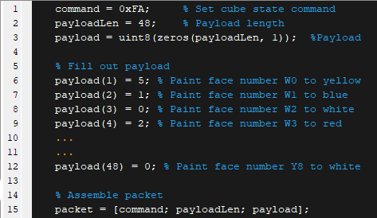

**NOTE: Use the enumeration from “Color Code” section to fill out the payload. The simulator will display an error if the cube state is not feasible.**

**See also: setCubeState.m (MATLAB), setCubeState.py (Python)**

* **Get Cube State command**

This command requests the state of the cube from the cube simulator.

|  |  |
| --- | --- |
| CMD | 0xFC (hex) |
| PAYLOAD LENGTH | N/A |
| PAYLOAD | N/A |

**Response**: 48 bytes corresponding to the cube state (48 movable faces).

**Code example (MATLAB)**

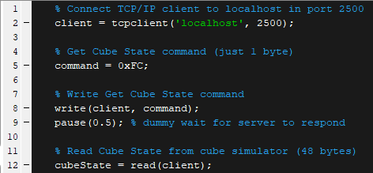

**NOTE: The cube state response has the same format as the Face Numbers diagram in “Set Cube Command” section.**

**See also: getCubeState.m (MATLAB), getCubeState.py (Python)**

* **Set Cube Moves command**

This command sets a list of moves to perform in the cube simulator.

|  |  |
| --- | --- |
| CMD | 0xFB (hex) |
| PAYLOAD LENGTH | N |
| PAYLOAD | N byte array |

**Code example (MATLAB)**

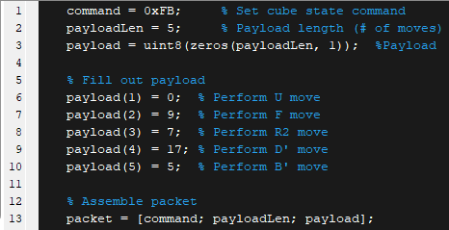

**NOTE: Use the enumeration from “Cube Movements code” section to fill out the payload. Since the payload length must be 1 byte, it may be performed up to 255 moves per packet.**

**See also: setCubeMoves.m (MATLAB), setCubeMoves.py (Python)**